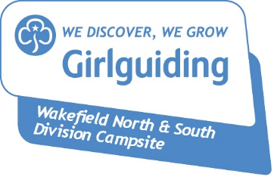
Wakefield North & South Division Campsite
Payment Slip
Please complete and return together with all monies due within one month of your event
Booking Reference Number
Name (Leader in charge)
Unit/Group Name
Phone number
Email address
Dates of Stay | Start:  Finish:

Payment details
Total number on site
Fee Category | Evening/Day/Weekend/ Overnight(s) | Wakefield/Guiding/Other
Base Fee (Per Night) | £
Extra User Fee (Per Night) | £
Other | £
Total | £
Deposit | £
Balance | £

Please take a moment to let us know what you thought about your stay

Is there anything you would like to recommend that may improve the Campsite / your experience?

☐ I have enclosed/transferred by BACS the remaining fees of £
(Cheques to be made payable to Wakefield Girlguide Camp A/c, BACS to Account: 70911879, Sort Code: 20-89-68)
☐ Please send me a receipt: enclosed SAE / email me at above address
☐ I would like to be kept informed of future events/offers/improvements at the Campsite through the Friends of Midgley Facebook Group

Signed Dated

Please return to: Midgley Camp Booking Secretary, 202 Bridge Road, Horbury, Wakefield, WF4 5PS
midgleybookings@gmail.com

