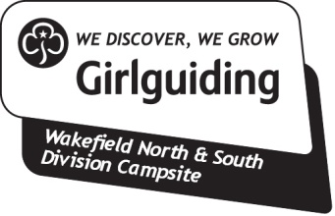
Hiring out the site to third parties

If you intend to hire out the campsite as a non-Guiding organisation or as a private individual, you should complete a Hirer's Agreement form.
This form is required as Girlguiding’s public liability insurance policy does not cover these occasions and therefore the information below must be completed.
Part A
The first part of the form (A) sets out the time, dates and costs of the hire for our records.
Part B
The second part of the form (B) requests that you, the hirer, agree that you will indemnify us for damage or injury. This means that you will either pay the costs of repair, or will pay compensation for the damage and / or injury incurred.
Organisations:
The form asks you to confirm that you have public liability insurance in place to cover the costs and compensation up to £5,000,000. Most large organisations will have public liability insurance but some informal groups may not. Girlguiding has its own Public Liability Insurance policy but we cannot add anyone to it. If you do not have any cover of your own, you must either arrange it or take the responsibility yourselves.
Private hirers:
You may be able to arrange insurance as part of their household policy for a party or one-off event. It is possible for us to make a claim against you personally if you do not have insurance.
As a hirer, you should make the be aware that, by signing the agreement, you are entering into a contract with us and failure to have a public liability insurance policy would be a breach of contract and a claim could be made against you.
The form should be completed in duplicate with a copy retained by the Campsite committee for our records and a copy given to you the hirer. The property management committee will store the forms securely. The forms shall be kept for 3 years after the cessation of the agreement.
Trustees:
Alison Hartley & Mary Emeny

Wakefield North Division Commissioner & Wakefield South Division Commissioner
As a site user, you are asked to abide by the following site guidelines: Follow the country code ...Respect the property and land – open fires only in the campfire circle ... No vehicles to be driven onto the site – please park on hard standing areas only ... Respect our neighbours – quiet times between 11pm -7am ... For further guidelines refer to the site handbook

