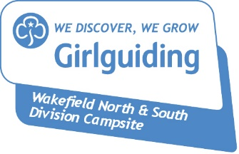
Wakefield North & South Campsite
Booking Form

Provisional verbal/email bookings will be held for two weeks (one week for those booking less than two weeks in advance)
If you do not confirm your booking (no money/no form) nor inform us of your intentions - you will lose your booking and may be liable to pay the full amount

Booking Reference Number
Name (Leader in charge)
Address
Telephone Number
Mobile
Email

Unit/Group Name
Division
County

Arrival Date |  | Arrival Time
Departure Date |  | Departure Time

Numbers… (estimated/actual)
Rainbows |  | Beavers
Brownies |  | Cubs
Guides |  | Scouts
Rangers |  | Explorers
Young Leaders |  | Network
18-30 Members |  | Scouters
Adult Leaders |  | Other men
Trefoil Guild |  | Other children (0-14)
Other women |  | Other young people (14-18)
☐ I have read and agree to abide by the Booking Conditions as outlined
☐ I have enclosed a completed indemnity letter/hire agreement form (non-Association users)
☐ I have enclosed/transferred by BACS a non-returnable deposit £_________
(cheques payable to Wakefield Girlguide Camp A/c, BACS to Account: 70911879, Sort Code: 20-89-68)
☐ I understand that the balance of the monies due should be paid WITHIN ONE MONTH OF the camp/overnight/event/meeting
☐ I/we require assistance in setting up the chemical toilets etc (for evening users only)
☐ For confirmation of booking: I have enclosed a SAE/please email me direct

Signed Dated

Please return to: Midgley Camp Booking Secretary, 202 Bridge Road, Wakefield, WF4 5PS
midgleybookings@gmail.com

